LACNIC

🌐 What Is LACNIC?
# Source: Chatgpt (GPT‑5 Mini) at [12/15/2025]
LACNIC stands for Latin America and Caribbean Network Information Centre. It is one of the five Regional Internet Registries (RIRs), responsible for managing:
- IPv4 and IPv6 address space
- Autonomous System Numbers (ASNs)
…for organizations in Latin America and the Caribbean.

🧠 Simple Definition:
# Source: Chatgpt (GPT‑5 Mini) at [12/15/2025]
LACNIC is the organization that allocates IP addresses and AS numbers to ISPs, data centers, and networks in Latin America and the Caribbean region.

🌍 Region Covered by LACNIC
# Source: Chatgpt (GPT‑5 Mini) at [12/15/2025]
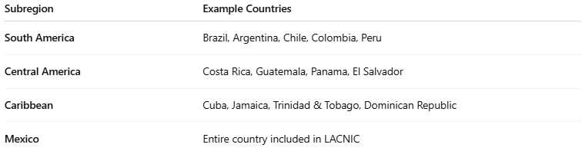

Subregion | Example Countries
South America | Brazil, Argentina, Chile, Colombia, Peru
Central America | Costa Rica, Guatemala, Panama, El Salvador
Caribbean | Cuba, Jamaica, Trinidad & Tobago, Dominican Republic
Mexico | Entire country included in LACNIC

🔧 LACNIC’s Core Responsibilities
# Source: Chatgpt (GPT‑5 Mini) at [12/15/2025]
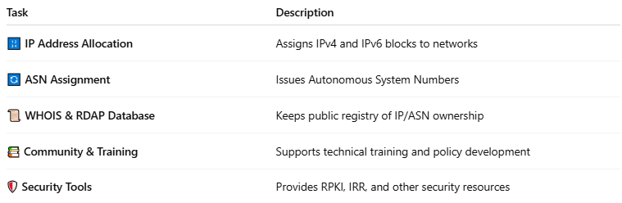

Task | Description
🔢 IP Address Allocation | Assigns IPv4 and IPv6 blocks to networks
🔄 ASN Assignment | Issues Autonomous System Numbers
📜 WHOIS & RDAP Database | Keeps public registry of IP/ASN ownership
📚 Community & Training | Supports technical training and policy development
🛡 Security Tools | Provides RPKI, IRR, and other security resources

🏢 Headquarters & Contact
# Source: Chatgpt (GPT‑5 Mini) at [12/15/2025]
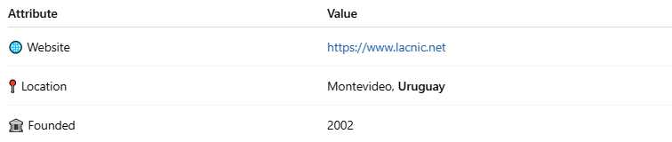

Attribute | Value
🌐 Website | https://www.lacnic.net
📍 Location | Montevideo, Uruguay
🏛 Founded | 2002

🧾 WHOIS Example (via LACNIC)
# Source: Chatgpt (GPT‑5 Mini) at [12/15/2025]
For IP: 179.0.0.0
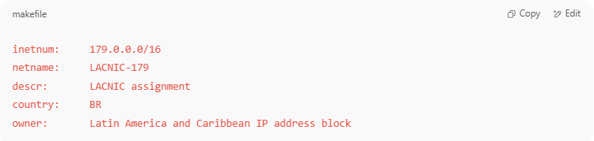
inetnum: 179.0.0.0/16
netname: LACNIC-179
descr: LACNIC assignment
country: BR
owner: Latin America and Caribbean IP address block

🧭 LACNIC vs Other RIRs
# Source: Chatgpt (GPT‑5 Mini) at [12/15/2025]
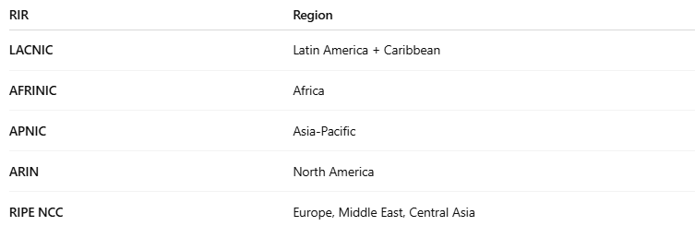

RIR | Region
LACNIC | Latin America + Caribbean
AFRINIC | Africa
APNIC | Asia-Pacific
ARIN | North America
RIPE NCC | Europe, Middle East, Central Asia

✅ Summary
# Source: Chatgpt (GPT‑5 Mini) at [12/15/2025]
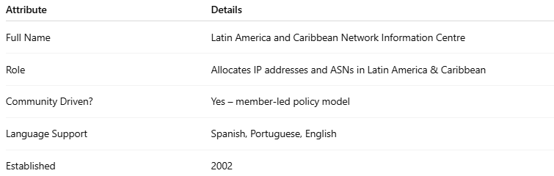

Attribute | Details
Full Name | Latin America and Caribbean Network Information Centre
Role | Allocates IP addresses and ASNs in Latin America & Caribbean
Community Driven? | Yes – member-led policy model
Language Support | Spanish, Portuguese, English
Established | 2002

